CDS CA1 Report

Pipeline Design

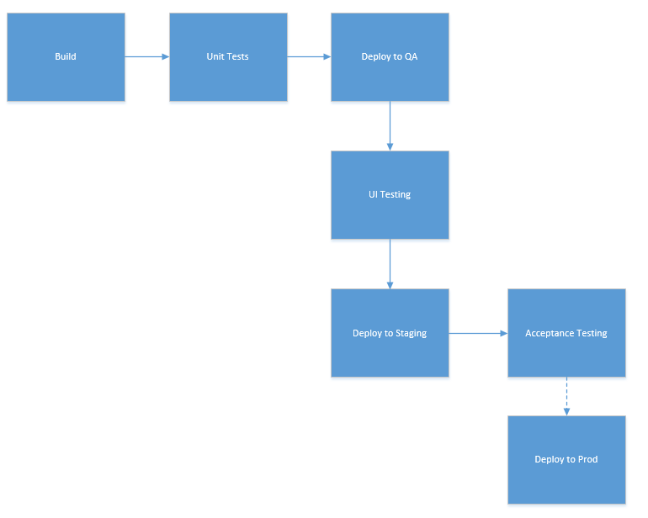

Have to configure in order to always deploy latest build

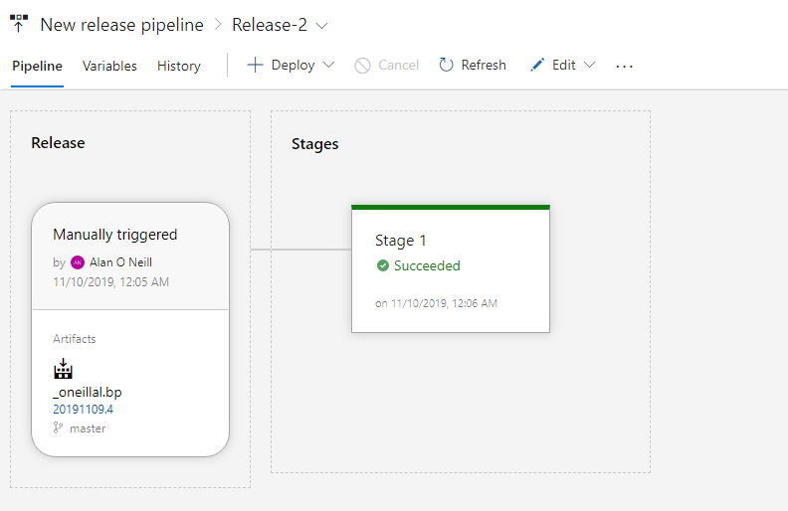

Continuous Deployment

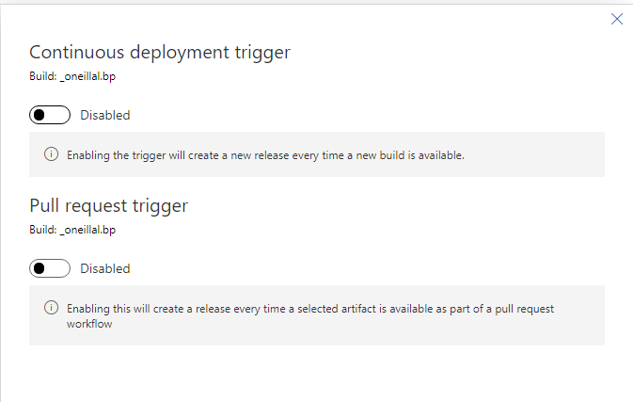

Spawns a new release once a new build drops

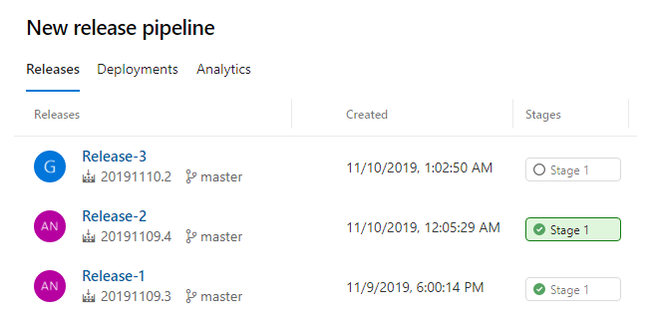

G icon tells that its GitHub who initiated the release.

Git in VS

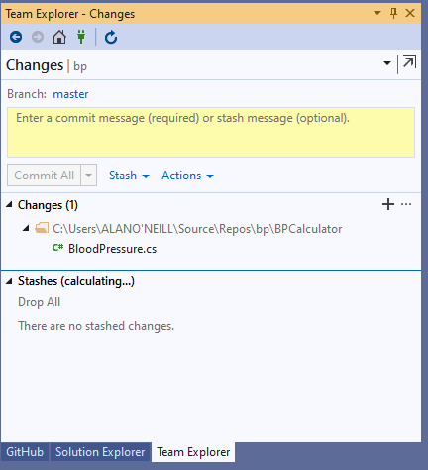

Unstaged change

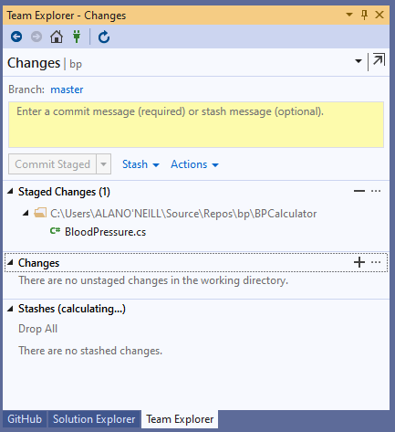

Staged

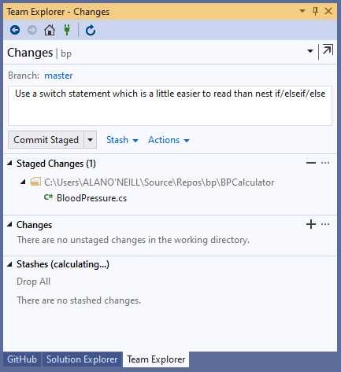

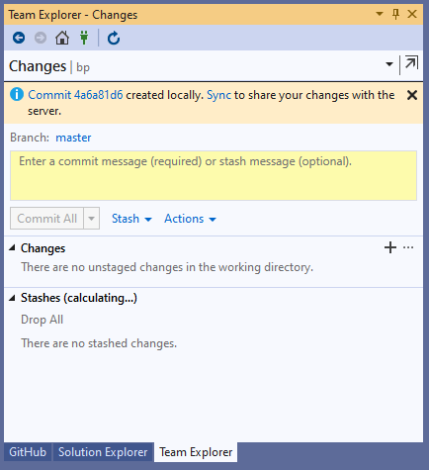

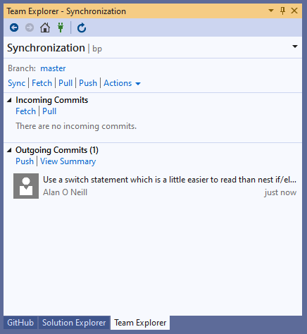

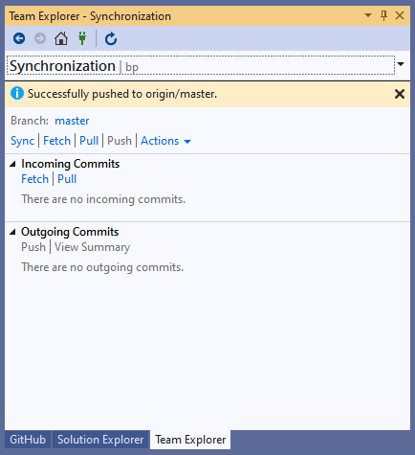

Build kicks in

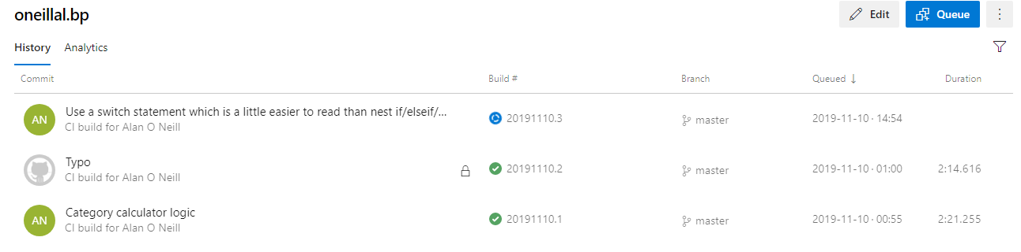

Release is triggered automatically

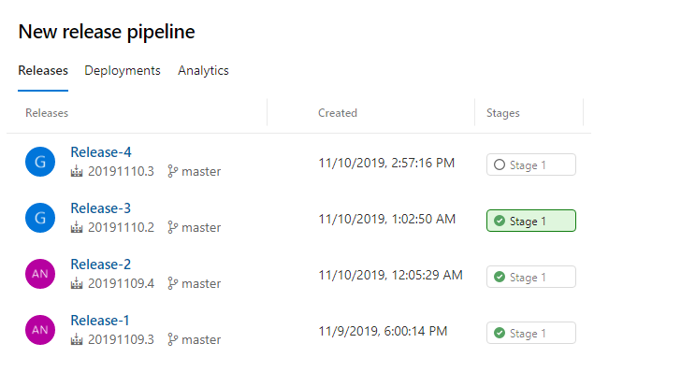

Pipeline Dashboard

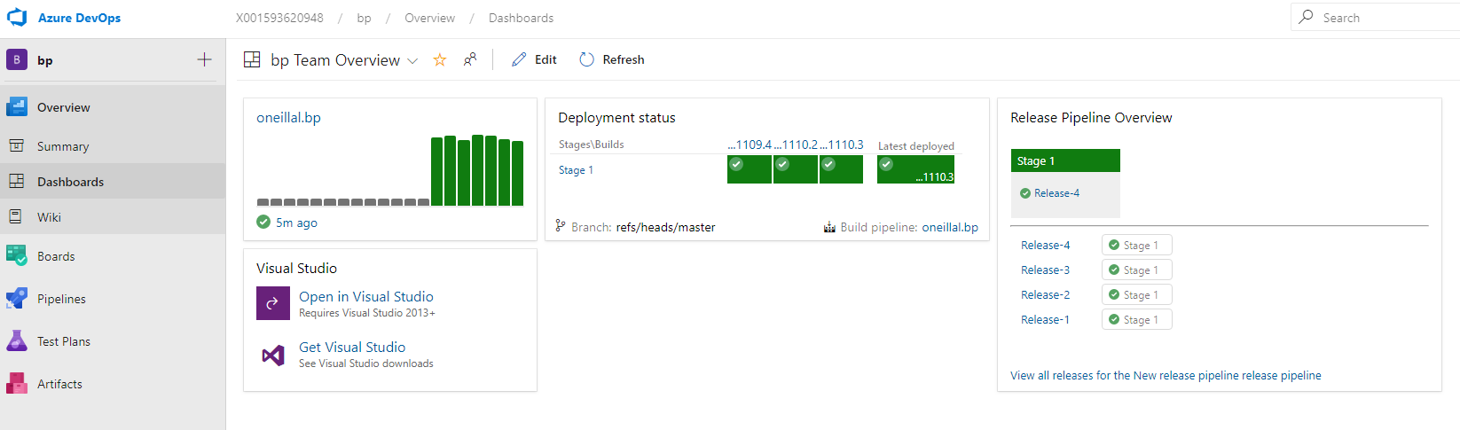

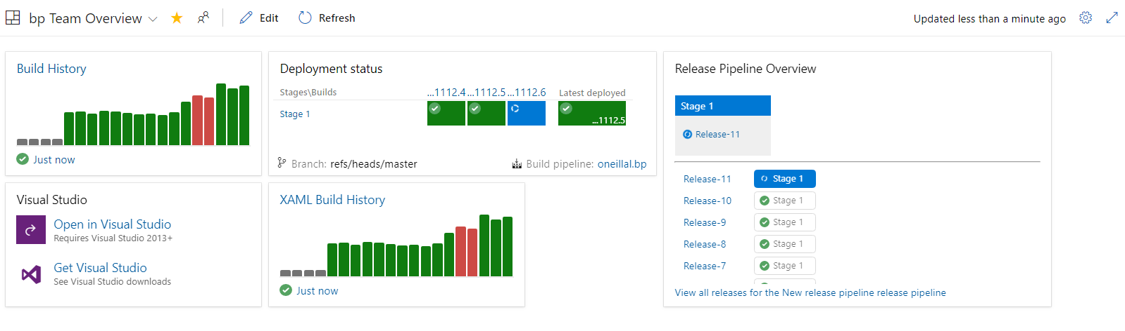

Unit Tests

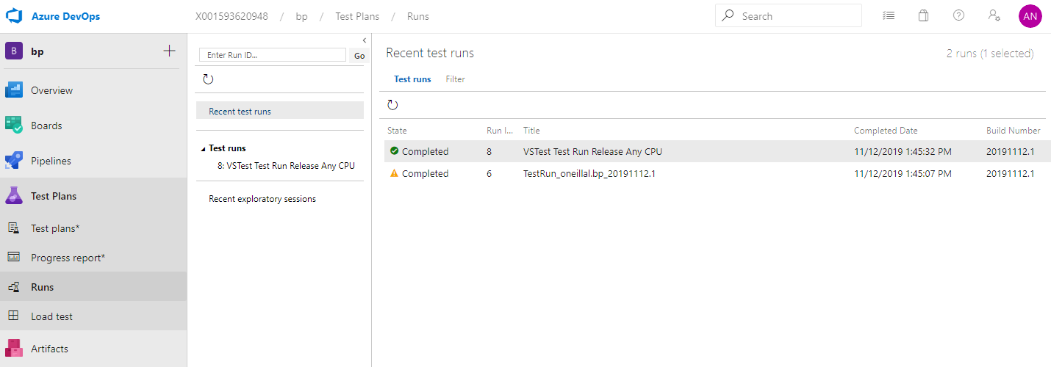

Unit test results

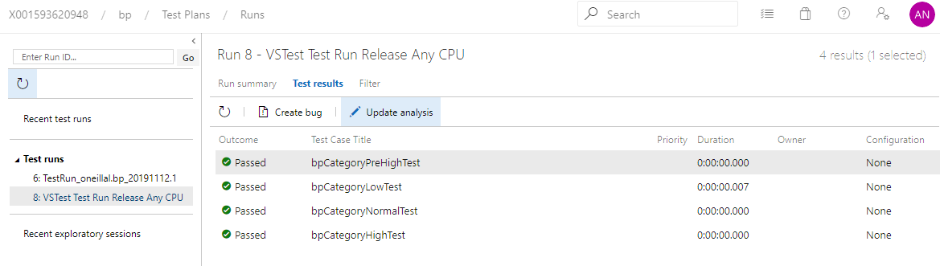

Sonar Code Analysis

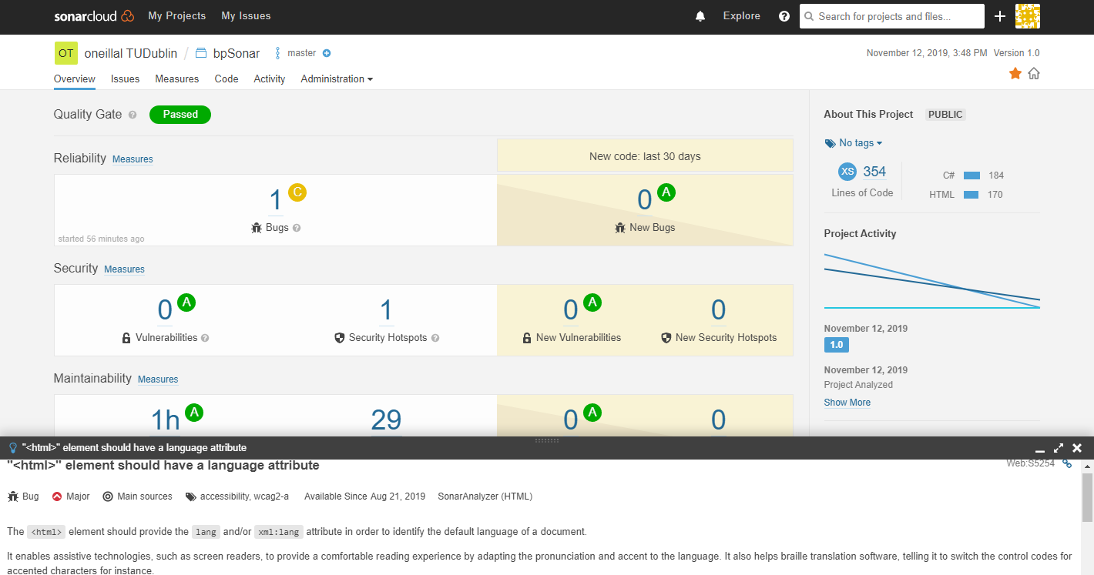

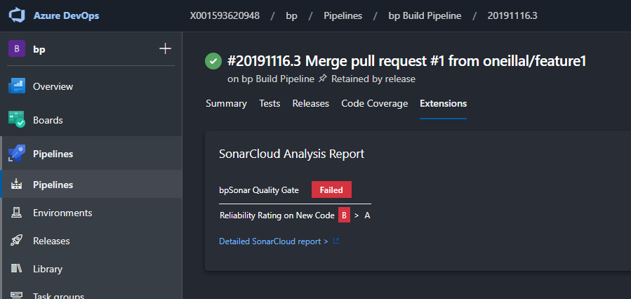

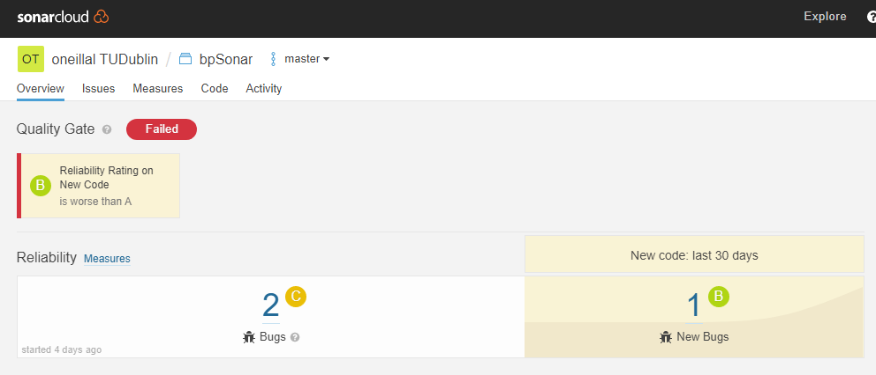

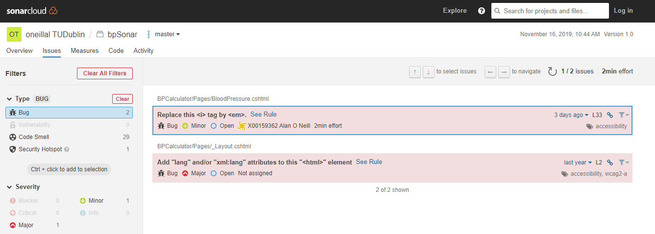

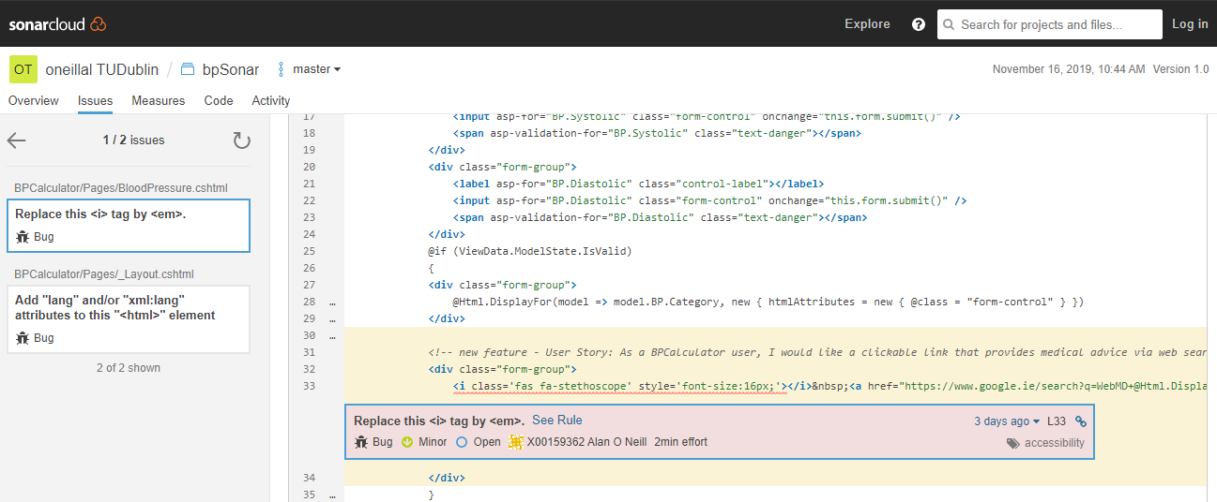

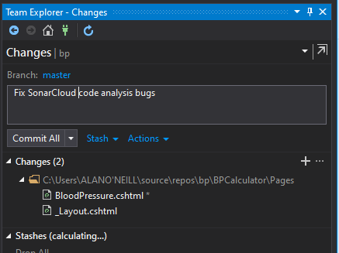

Failed because of YAML formatting…

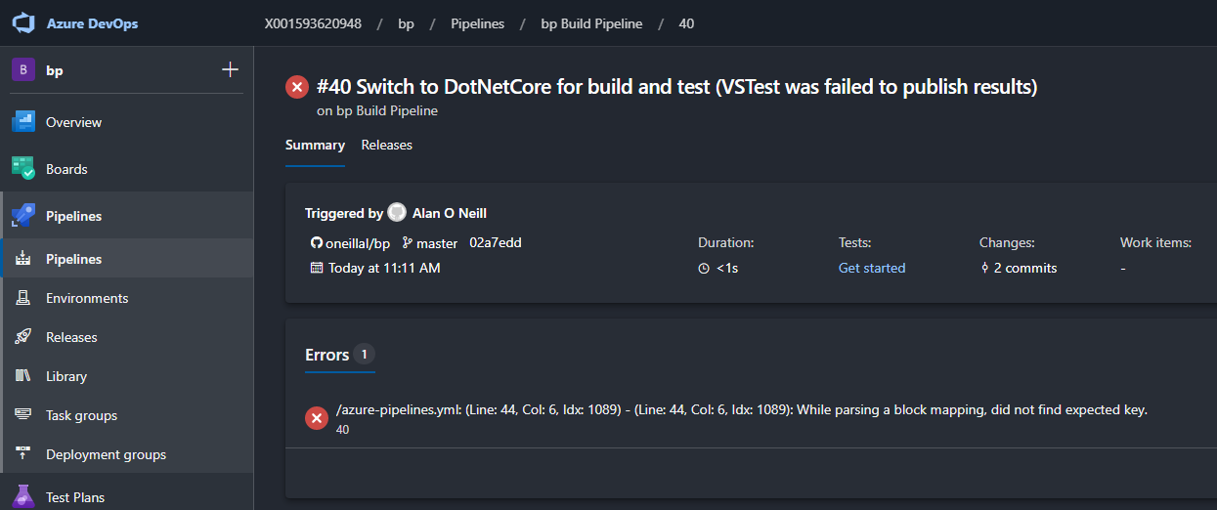

Introduced YAML validation to catch invalid pipeline YAML and wasting build cycles

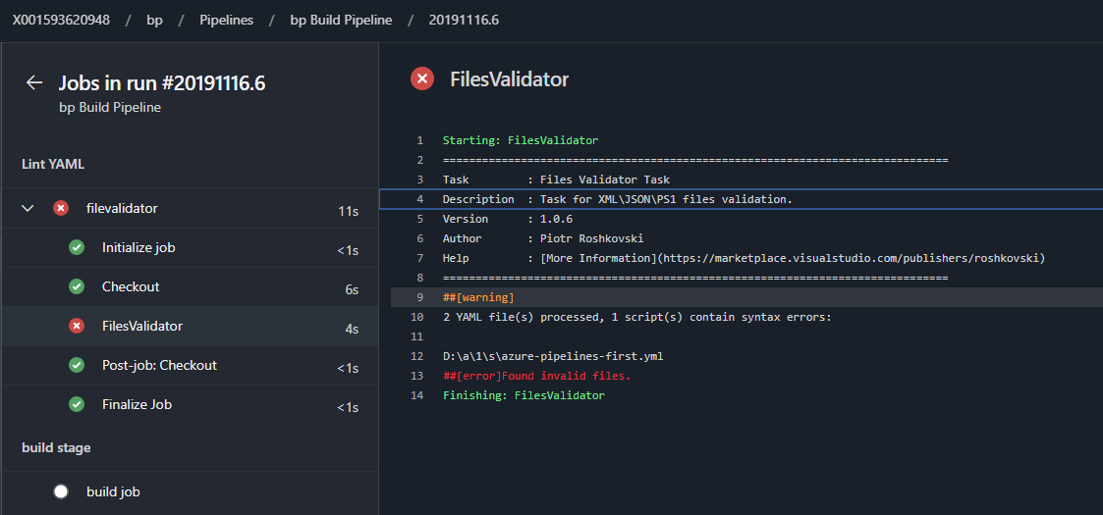

OWASP Dependency Check

Installed the tool from the marketplace

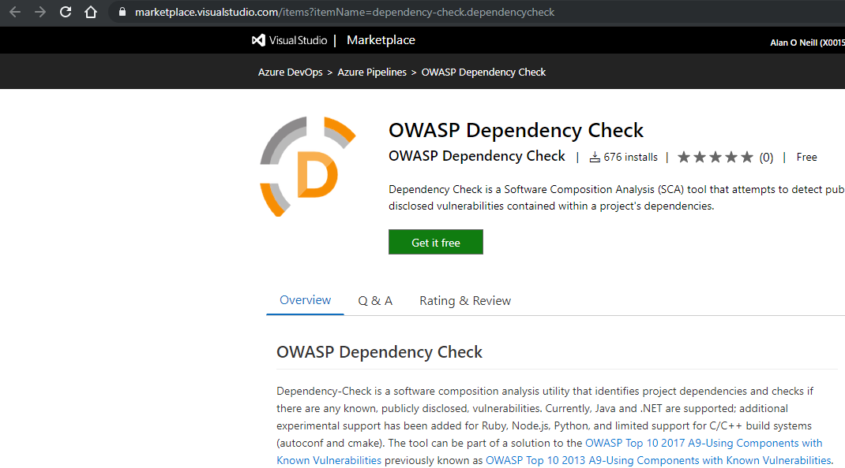

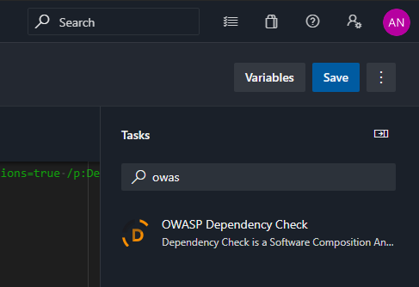

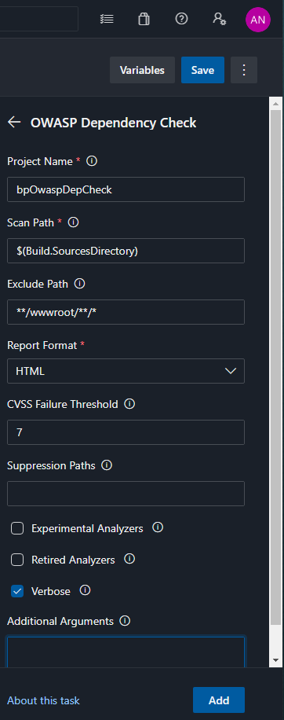

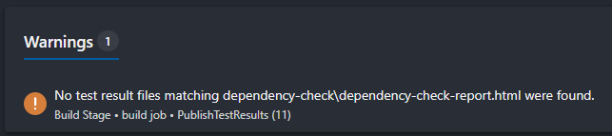

<https://docs.microsoft.com/en-us/azure/devops/pipelines/build/variables?view=azure-devops&tabs=yaml>

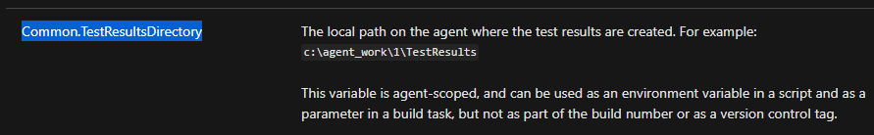

Publish OWASP report

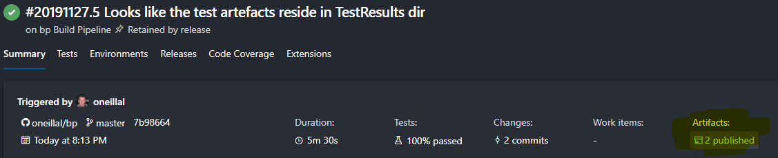

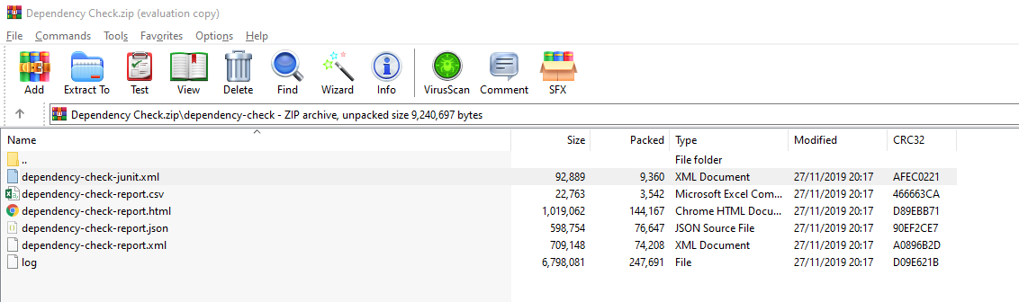

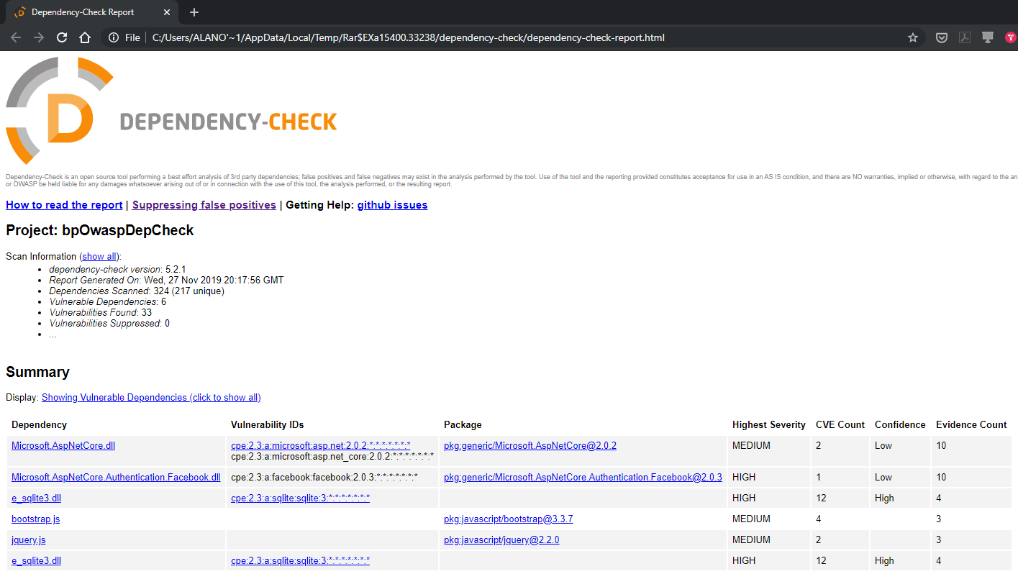

Using PublishTests we can get the output to display in the Tests view of the Pipeline

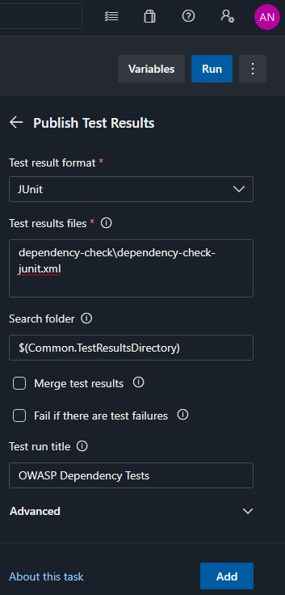

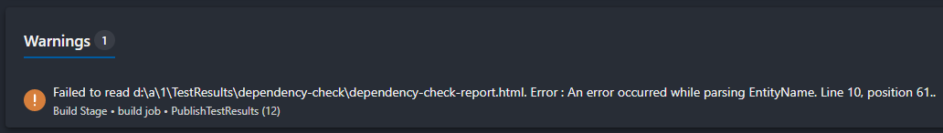

Doesn’t support displaying the HTML. Seems you have to use something like JUnit or XUnit

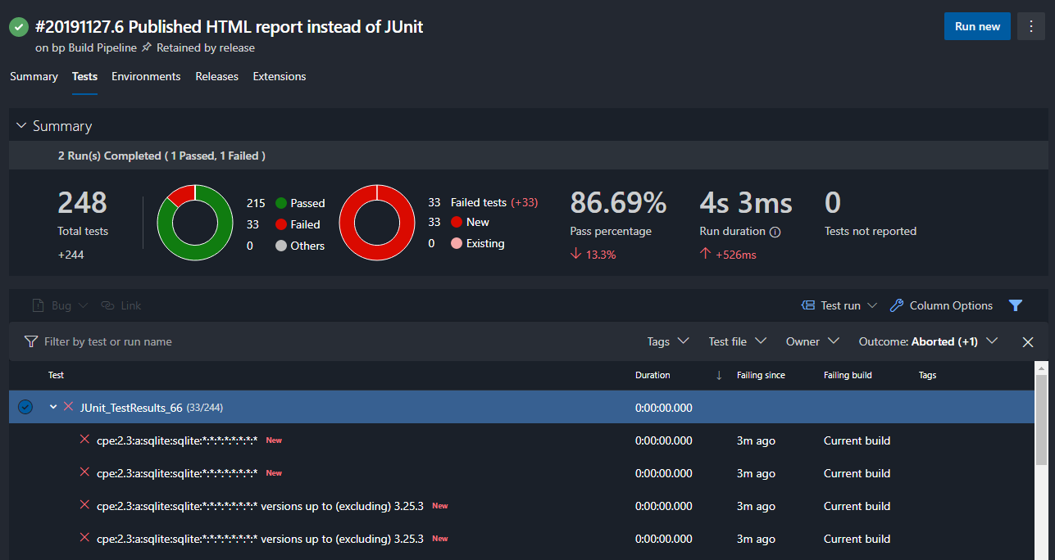

Lots of failed tests now because of OWASP…will try fix

Output too verbose anyway…need to reduce

Existing failed tests

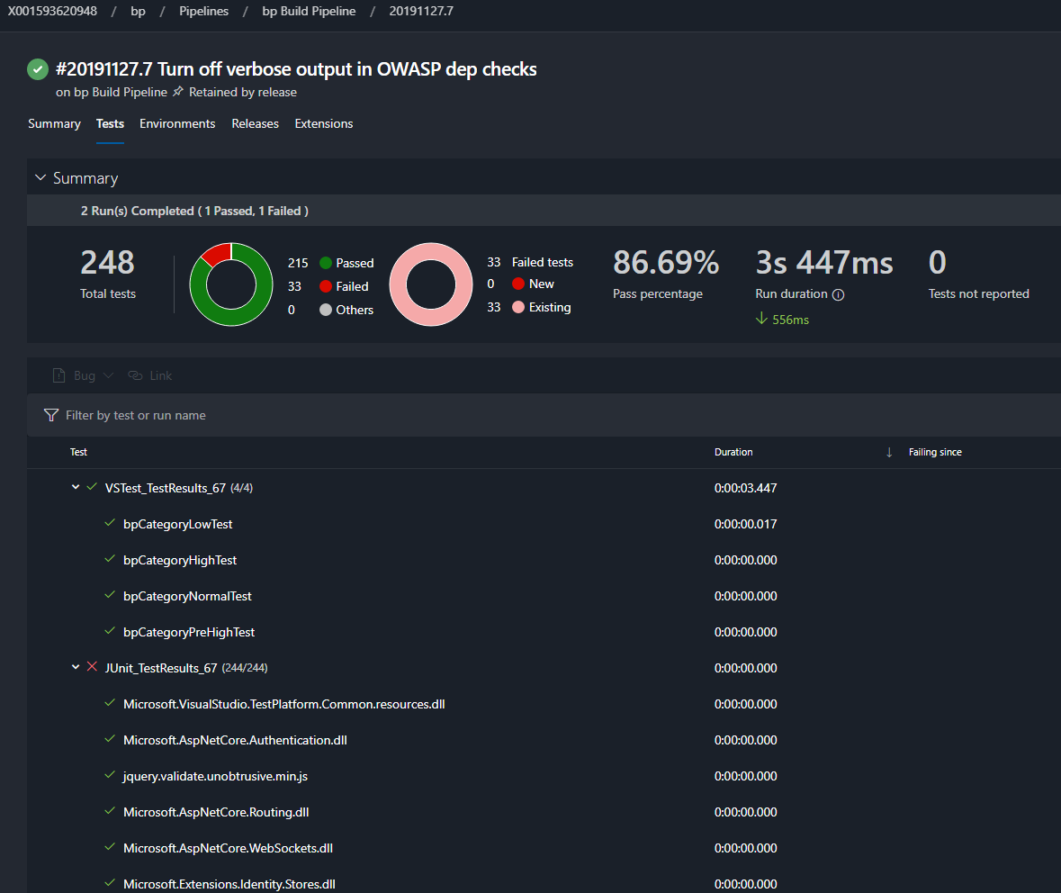

Analytics

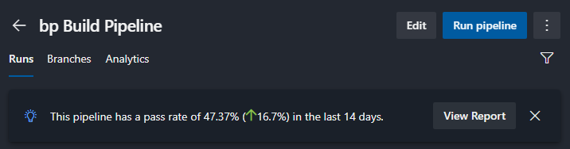

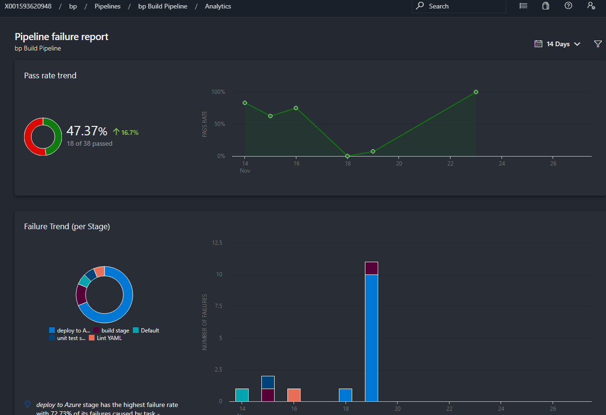

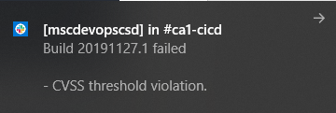

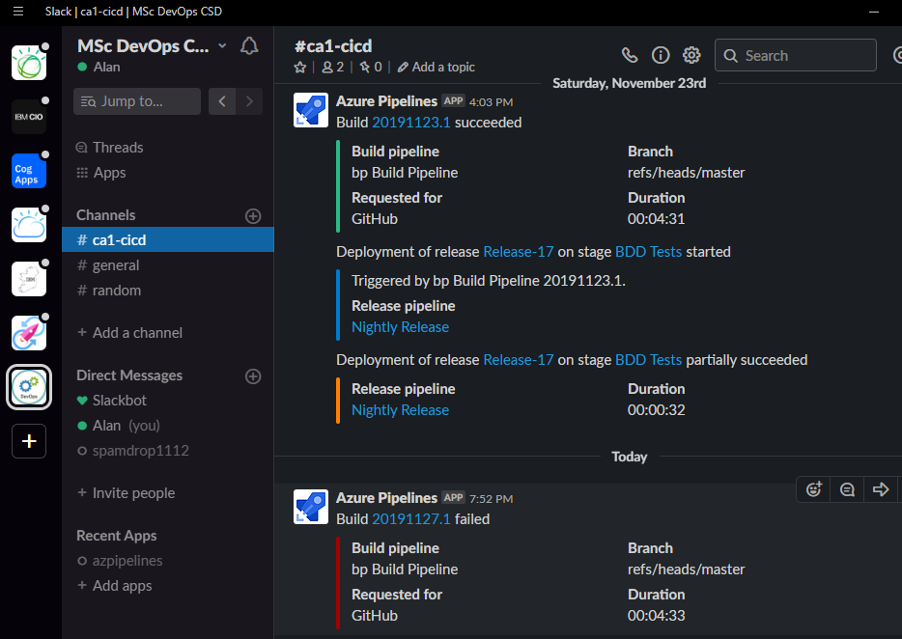

GitHub Build Dependency Checks

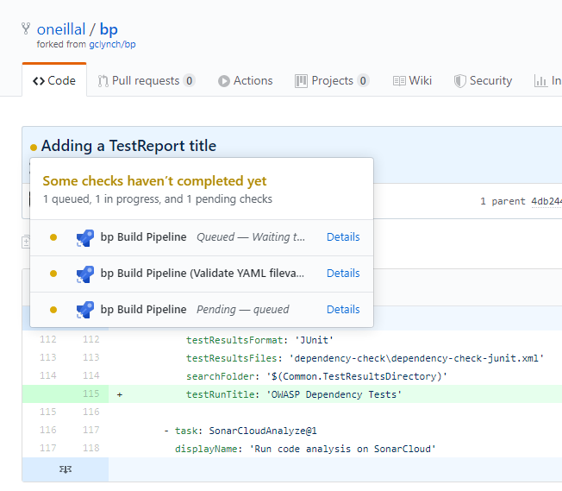

Build status badge…

Added markdown to display the hipster build status badges![![Build Status](https://dev.azure.com/X001593620948/bp/_apis/build/status/bp%20Build%20Pipeline?branchName=master)](https://dev.azure.com/X001593620948/bp/_build/latest?definitionId=4&branchName=master)

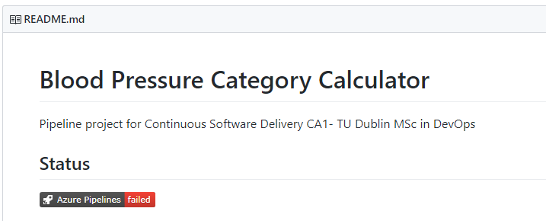

Selenium Tests

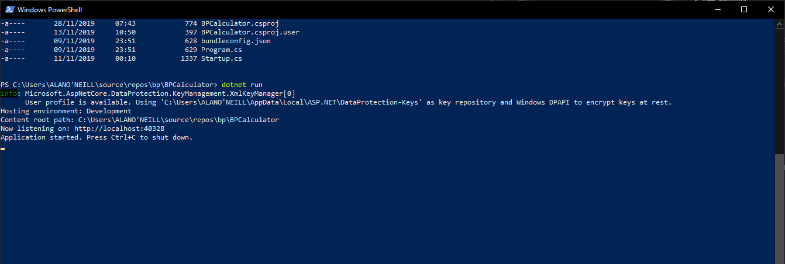

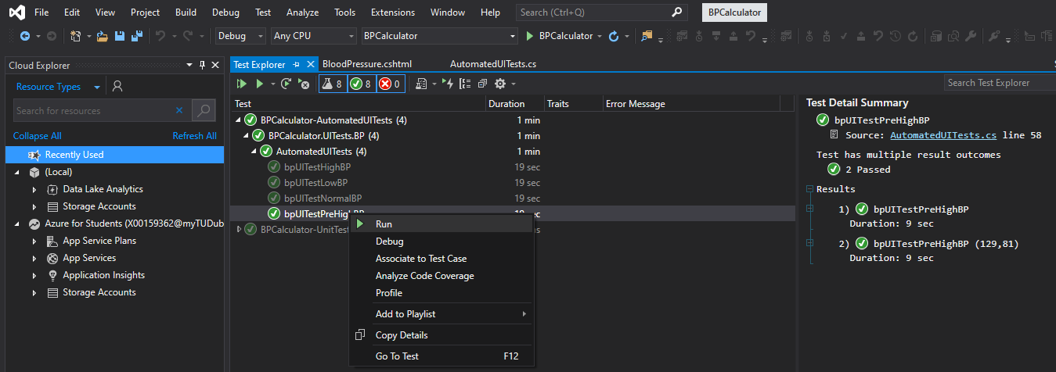

Added a test step post deploy against the deployed instance and captured the tests. Had some issues trying to figure out the paths to run the Selenium tests.

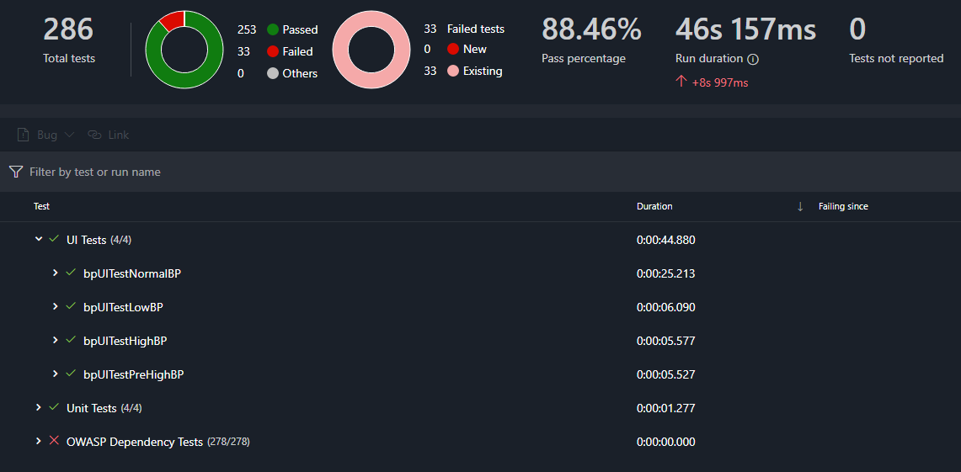

Security

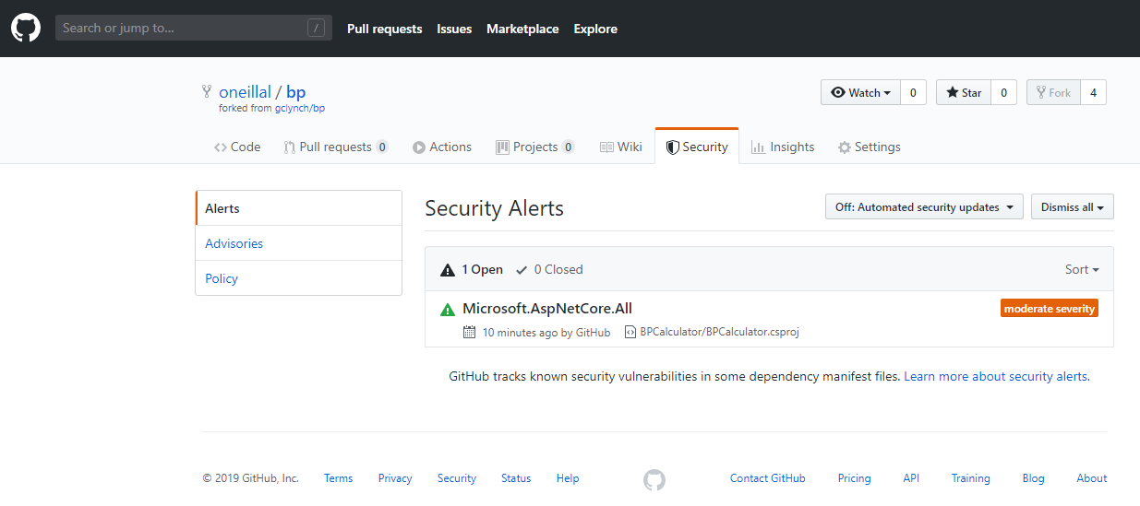

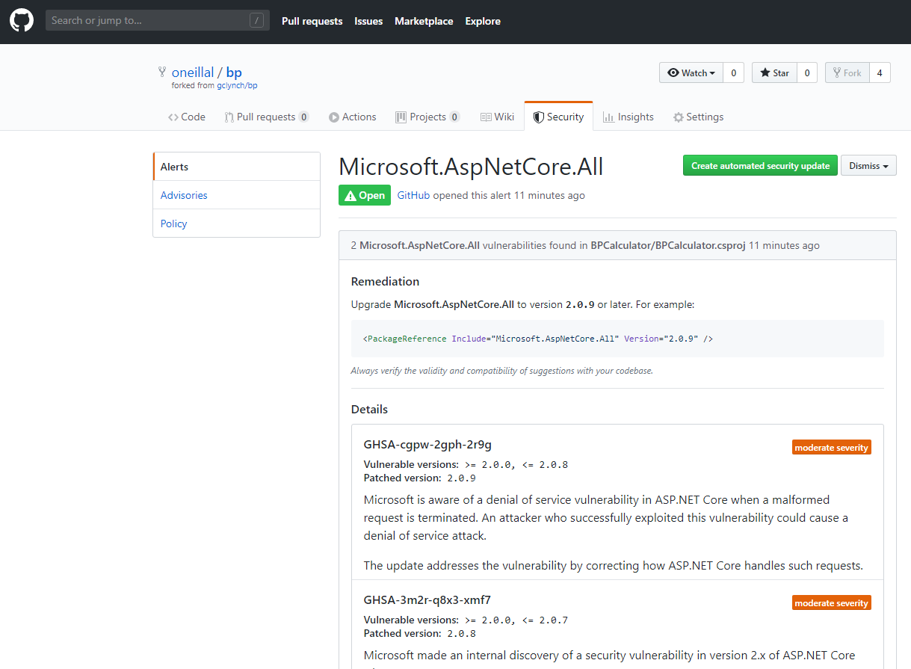

UAT Testing

Used a cucumber framework called SpecFlow: <https://specflow.org/getting-started/>

The guide was a little confusing and I couldn’t find a way to generate the Feature file. After deleting and recreating projects and messing with dependency versions, turns out that I needed a VS extension in order to work with the artefacts through wizards even though it said it’s not needed. Probably true but I installed it anyway.

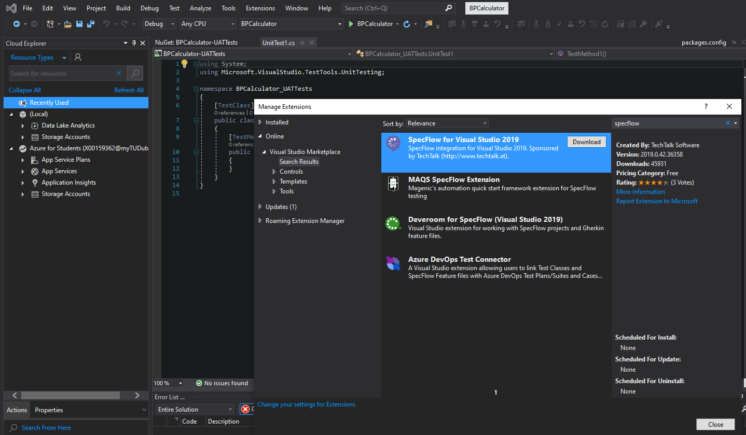

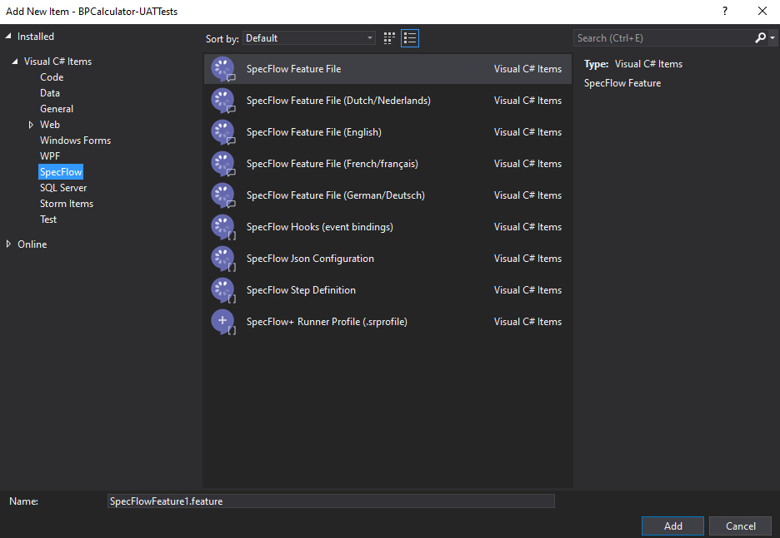

Approval Gate for Production

In Environments > prod and under the ellipsis menu, select Approval and checks and add approver(s):

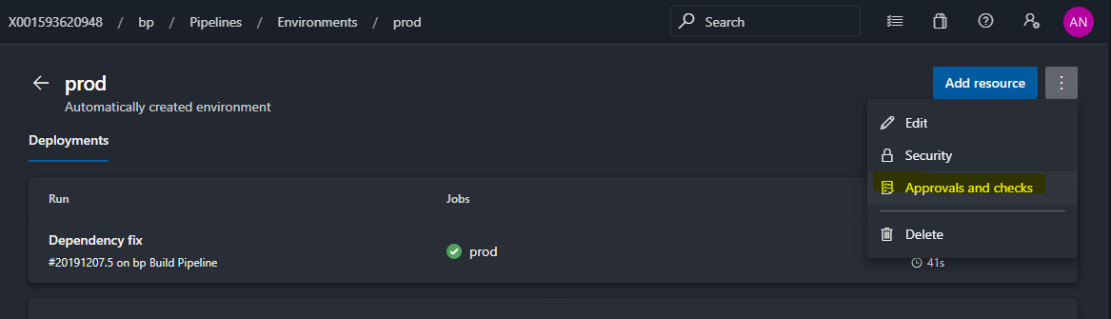

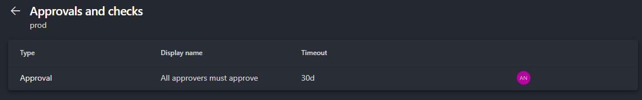

Deployment step to prod is waiting for approval…

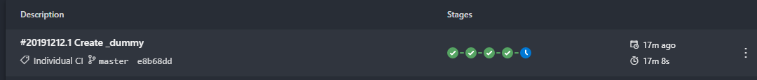

Approving deployment to Production through Azure Pipelines Slack app.

